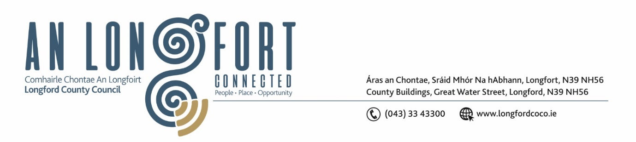

LONGFORD MUNICIPAL DISTRICT

Please note meeting will be held in the Council Chamber, Aras an Chontae and via Microsoft Teams

20 July 2023

To: Each Member of Longford Municipal District.

Dear Member,

You are requested to attend the Meeting of Longford Municipal District to be held in the Council Chamber, Aras an Chontae and via Microsoft Teams on Wednesday 26 July 2023 at 4pm to transact business, as set out on the agenda hereunder.

Yours sincerely,

_______________
Claire McNabola
Meetings Administrator

AGENDA

Prayer before meeting.

1. Confirmation of Minutes:

- Longford Municipal District Meeting held on Wednesday 28 June 2023 – enclosed.
- Longford Municipal District Annual Meeting held on Wednesday 28 June 2023 – enclosed.

2. Matters arising from Minutes.

3. Declaration of Interest by Members.

4. Management Report

5. Consideration of Draft Longford Appointed Stands (Street Service Vehicles) Bye Laws 2023 – enclosed

6. Consideration of the Taking in Charge of Road at Palace Crescent – enclosed

7. Consideration of Part VIII No. 108 – Aghafad Pedestrian and Cyclist Scheme

8. Notices of Motions, submitted by Councillors, as listed hereunder –
Councillor Gerry Hagan
- I call on Longford MD to carry out road marking reinstatement works on all loading bays in the town. These loading bay markings are worn away and a lot of cars are parking in these loading bays as a result.

- I call on Longford MD to install flower boxes on the wide footpath on Main Street outside Kenny’s Shop. There are a lot of cars and vans parking up on the new path at peak times and this may prevent this from reoccurring.

Councillor Uruemu Adejinmi
I call on Longford County Council to look at providing road markings and signage at Derryharrow Cross for the guidance of road users.

